Problem 1: Display the bike names and list prices for bikes costing $5,000 or more. Order the results in descending order based on the list price.
USE BikeStores
GO
SELECT product_name, list_price
FROM Production.Products
WHERE list_price >= 5000
ORDER BY list_price DESC;
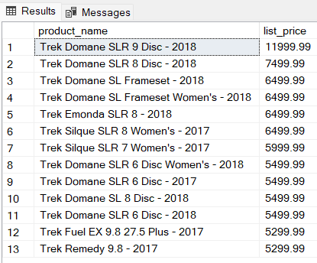

Problem 2: Present a list of the bikes made by a company called “Haro” in alphabetical order.
USE BikeStores
GO

SELECT product_name
FROM Production.Products INNER JOIN Production.Brands
ON Production.Products.brand_id = Production.Brands.brand_id
WHERE Production.Brands.brand_name = 'Haro'
ORDER BY product_name;
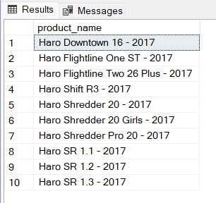

Problem 3: Select customer records for customers residing in the 14450 zip code.
USE BikeStores
GO

SELECT *
FROM Sales.Customers
WHERE zip_code = '14450'
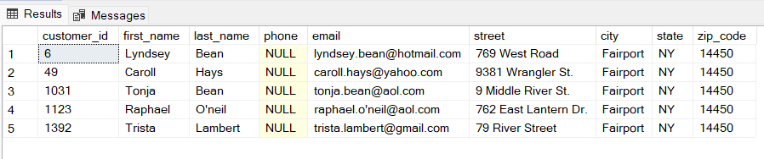

Problem 4: List the first and last names of staff members whose manager is Mireya Copeland.
USE BikeStores
GO

SELECT Sales.Staffs.first_name, Sales.Staffs.last_name
FROM Sales.Staffs INNER JOIN Sales.Staffs M
ON Sales.Staffs.manager_id = M.staff_id
WHERE M.first_name = 'Mireya' AND M.last_name = 'Copeland'
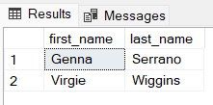

Problem 5: The company is now selling bikes from a company called GT Bicycles. Enter a new record into the database to reflect this change.
USE BikeStores
GO

INSERT INTO Production.Brands (brand_name)
VALUES ('GT Bicycles');

SELECT *
FROM Production.brands
WHERE brand_name = 'GT Bicycles'
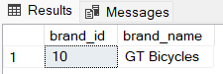

Problem 6: Update the amount of stock for the bike with product_id = 198 at the store with store_id = 2. The new stock amount should be 20.
USE BikeStores
GO

UPDATE Production.stocks
SET quantity = 20
WHERE product_id = 198 AND store_id= 2;

SELECT *
FROM Production.stocks
WHERE product_id = 198 AND store_id= 2;
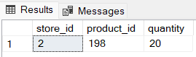

Problem 7: Show bike names and the total sales amounts for transactions involving bikes costing $10,000 or more. The total sales amount is the product of the bike order item list price, quantity sold, and sale discount.
USE BikeStores
GO

SELECT P.product_name, OI.list_price*quantity*discount AS SalesAmt
FROM Sales.Order_Items OI INNER JOIN Production.Products P
ON OI.product_id = P.product_id
WHERE OI.list_price >= 10000;
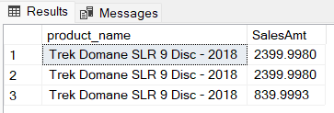

Problem 8: Provide a distinct list of the states in alphabetical order where the company’s customers reside.
USE BikeStores
GO

SELECT DISTINCT State
FROM Sales.Customers
ORDER BY State
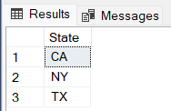

Problem 9: Display the full names of all staff personnel in First_Name, “ ” , Last_Name format. Use the built-in CONCAT() function for this query.
USE BikeStores
GO

SELECT First_Name + ' ' + Last_Name AS 'Staff Name'
FROM Sales.Staffs;

SELECT CONCAT (First_Name, ' ', Last_Name) AS 'Staff Name'
FROM Sales.Staffs;
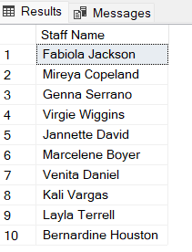

Problem 10: Show the bikes that have zero stock at the Texas (TX) store.
USE BikeStores
GO

SELECT product_name, state, quantity
FROM Production.Products P INNER JOIN Production.Stocks S
ON P.product_id = S.product_id
INNER JOIN Sales.Stores ST
ON S.store_id = ST.store_id
WHERE ST.state = 'TX' AND S.quantity = 0
ORDER BY product_name;
